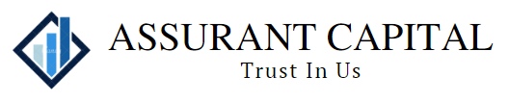
Assurant capital, N.A.

To: SBMORGAN BANK NATIONAL ASSOCIATION

Date: 17-Nov-2023

ATTN: NON AGENTED SERVICING
Phone: 01918067906064

Email: XYZ@SBMCHASE.COM

Re: BRUCE LEE INC USD 150MM FEB17 / REVOLVING CREDIT LINE1/BRUCE LEE 100040

Deal CUSIP: 01447LAE2
Deal ISIN: US01447LAE20
Facility CUSIP: 01447LAF9
Facility ISIN: US01447LAF94
Borrower MEI: US1L064164
Lender MEI: US1L019291

The BRUCE LEE INC has elected to borrow under the SOFR Simple ARR Option a total of USD 20,000,000.00 effective 20-Nov-2023.

Previous Global Principal Balance III USD 210,000,000.00
New Global Principal Balance the USD 230,000,000.00

Previous Lender/perticipant share : USD 21,000,000.00
New Lender/participant share # USD 23.000.000.00

Your Share of the borrowing is USD 2,000,000.00

SOFR Simple ARR Rate # 5.320000%
Spread : 1.250000%
Spread Adjustment ID 0.100000%
All in Rate : 6.670000%

Please remit USD 2,000,000.00 on the effective date.

For : SBMORGAN BANK NATIONAL ASSOCIATION
To: Assurant capital NA Charlotte

ABA Number: 026006996
Attn : SLC OPERATIONS
Account No : 13660123456789

